Reference number of working document: ISO/TC 000/SC 0 N 000
Date: yyyy-mm-dd
Reference number of document: ISO/WD nnn-n
Committee identification: ISO/TC 000/SC 0/WG 0
Secretariat: XXXX
Space Systems – Space Solar Panels – Spacecraft Charging Induced Electrostatic Discharge Test Methods

Warning
This document is not an ISO International Standard. It is distributed for review and comment. It is subject to change without notice and may not be referred to as an International Standard.
Recipients of this draft are invited to submit, with their comments, notification of any relevant patent rights of which they are aware and to provide supporting documentation.

Copyright notice
This ISO document is a working draft or committee draft and is copyright-protected by ISO. While the reproduction of working drafts or committee drafts in any form for use by participants in the ISO standards development process is permitted without prior permission from ISO, neither this document nor any extract from it may be reproduced, stored or transmitted in any form for any other purpose without prior written permission from ISO.
Requests for permission to reproduce this document for the purpose of selling it should be addressed as shown below or to ISO’s member body in the country of the requester:
Reproduction for sales purposes may be subject to royalty payments or a licensing agreement.
Violators may be prosecuted.
Contents Page

Foreword
Introduction
- Scope
- Terms and Definitions
- Symbols (and abbreviated terms)
- Tailoring
- Test Items
- Preliminary Tests for ESD Statistics
  - ESD inception threshold
    - Purpose
    - Test facility
    - Test coupon
    - External circuit
    - Test procedures
    - Estimation of number of ESD events in orbit
- Qualification Test for Secondary Arc
  - Purpose
  - Triggering method and test facility
  - External circuit
  - CIC gap test coupon and procedures
  - Panel test coupon and procedures
  - Success criteria
- Characterization Tests for Robustness to ESD and Plasma Interaction
  - Power degradation
    - Purpose
    - Test facility
    - Test coupon
    - External circuit
    - Test procedures
  - Secondary arc
    - Purpose
    - Triggering method and test facility
    - Test coupon
    - External circuit
    - Test procedures
  - Power leakage to plasma
    - Purpose
    - Test facility
    - Test coupon
    - External circuit
    - Test procedures
- Test Report Guidelines
Annex A (informative) Plasma Interaction and Electrostatic Discharge Effects on Solar Array
- Plasma environment in orbit
- Spacecraft surface charging
- Electrostatic discharge on solar array
- Detrimental effects of ESD
- Power leakage from solar array to plasma
Annex B (informative) Spacecraft charging analysis
Annex C (informative) ESD events analysis
Annex D (normative) External circuit of secondary arc phenomena
Annex E (informative) Solar cell current injection test
Annex F (informative) Solar cell I-V characteristics measurement
Annex G (informative) Solar array back surface test

Bibliography

Foreword
ISO (the International Organization for Standardization) is a worldwide federation of national standards bodies (ISO member bodies). The work of preparing International Standards is normally carried out through ISO technical committees. Each member body interested in a subject for which a technical committee has been established has the right to be represented on that committee. International organizations, governmental and non-governmental, in liaison with ISO, also take part in the work. ISO collaborates closely with the International Electrotechnical Commission (IEC) on all matters of electrotechnical standardization.
International Standards are drafted in accordance with the rules given in the ISO/IEC Directives, Part 2.
The main task of technical committees is to prepare International Standards. Draft International Standards adopted by the technical committees are circulated to the member bodies for voting. Publication as an International Standard requires approval by at least 75 % of the member bodies casting a vote.
ISO nnn-n was prepared by Technical Committee ISO/TC 20, Aircraft and space vehicles, Subcommittee SC 14, Space systems and operations.
Introduction
This standard provides test methods for plasma interaction and electrostatic discharge on space solar array panels.

Space Systems – Space Solar Panels – Spacecraft Charging Induced Electrostatic Discharge Test Methods

Scope
This standard provides qualification and characterization test methods to simulate plasma interactions and electrostatic discharges on solar array panels in space. This standard covers solar array panels made of crystalline silicon, GaAs or Multi-junction solar cells. This standard addresses only surface discharges on solar panels.

Terms and Definitions
For the purposes of this document, the following terms and definitions apply.

  - Absolute capacitance
Capacitance between satellite body and the ambient plasma
  - Active gap
A gap between solar cells across which a potential difference is present
  - Blow-off
Emission of negative charges into space due to an electrostatic discharge
  - Collisionless plasma
Mean free paths of electron-neutral, ion-neutral and coulomb collisions are longer than the scale length of interest, e.g. chamber length.
  - Deep dielectric / Bulk charging
Electrical charge deposition within the bulk of dielectric materials
  - Differential charging
Spacecraft charging where any two points are charged to different potentials
  - Differential capacitance
Capacitance between any two points in spacecraft, especially the insulator surface and the spacecraft body
  - Differential voltage
Potential difference between any two points in spacecraft, especially the insulator surface and the spacecraft body, during differential charging
  - Electric breakdown
Failure of the insulation properties of a dielectric, resulting in a sudden release of charge with possible damage to the dielectric concerned
  - Electric propulsion
Spacecraft propulsion system where the thrust is generated by accelerating charged particles that are neutralized before they are ejected to produce a jet.
  - Electrostatic discharge
Sudden release of charge by an electrostatic breakdown
  - Gap distance
Distance between biased cells
  - Glow discharge
Gaseous discharge with a surface glow near the cathode surface. The origin of the ionized gas is mostly ambient neutral gas molecules, rather than metal vapor from the cathode surface.
  - Internal charging
The deposition of electrical charges on conducting or insulating materials inside an enclosed space
  - Inverted potential gradient
The result of differential charging where the insulating surface or dielectric reaches a positive potential with respect to the neighboring conducting surface or metal: PDNM (Positive Dielectric Negative Metal)
  - Non-sustained arc
Passage of current from an external source through a conductive path that lasts only when primary discharge current flows. See Fig.1.
  - Normal potential gradient
The result of differential charging where the insulating surface or dielectric reaches a negative potential with respect to the neighboring conducting surface or metal: NDPM (Negative Dielectric Positive Metal)
  - Permanent sustained arc
Passage of current from an external source through a conductive path that keeps flowing until the external source is intentionally shut-down. Some permanent sustained arc may leave a permanent conductive path even after the shut-down. See Fig.1.
  - Power generation voltage
Potential difference between the positive and negative terminals of a solar array string
  - Primary arc
Primary discharge under an inverted potential gradient
  - Primary discharge
Initial electrostatic discharge which, by creating a conductive path, can trigger a secondary arc. The current includes blow-off current and surface flashover current. See Fig.1.
  - Punch-through
Dielectric breakdown between two sides of an insulator material
  - Ram
The space in front and adjacent to a spacecraft where the plasma density is enhanced by a moving spacecraft
  - Satellite capacitance
Absolute capacitance
  - Secondary arc
Passage of current from an external source, such as a solar array, through a conductive path initially generated by a primary discharge. See Fig.1 for definition of various stages of secondary arc.
  - Secondary arc threshold voltage
Minimum voltage which in association with the minimum current, makes the primary ESD transition into a secondary arc
  - Snapover
Phenomenon caused by secondary electron emission that can lead to electron collection on insulating surfaces in an electric field
  - Solar array front surface
Solar array surface where solar cells are laid down: the side of a solar panel that normally faces the sun
  - Solar array back surface
Solar array surface where solar cells are not laid down: the side of a solar panel that normally faces away from the sun
  - Surface charging
The deposition onto, or the removal of electrical charges from external and/or internal surfaces
  - Surface flashover
Surface discharge laterally propagating over a dielectric material, sometimes called a 'brushfire discharge
  - Temporary sustained arc
Passage of current from an external source through a conductive path that lasts longer than a primary discharge current pulse but terminates itself without leaving a permanent conductive path. See Fig.1.
  - Trigger arc
Same as primary arc
  - Wake
The trail of rarefied plasma left behind by a moving spacecraft

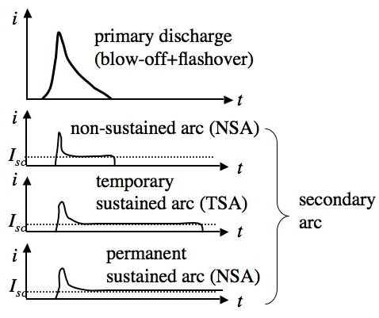
Figure 1: Various stages of secondary arc. The primary discharge is fed by absolute and differential capacitances. The secondary arc is fed by the solar array power. The current I_{sc} represents the short-circuit current of one or more of solar array circuit.

Symbols (and abbreviated terms)
eV electron volt,
Note 1eV=1.602x10⁻¹⁹J
CIC Coverglass-interconnect-cell
ESD electrostatic discharge
EMC electromagnetic compatibility
GEO Geosynchronous Orbit
IPG inverted potential gradient
LEO Low Earth Orbit
NPG normal potential gradient
NSA non-sustained arc
PA primary arc
PD primary discharge
PEO Polar Earth Orbit
PI plasma interaction
PSA permanent sustained arc
SAS solar array simulator
TSA temporary sustained arc

Tailoring
Specifications described in this standard are tailorable upon agreement between customers and test experts.

Test Items
Note: If the reader is not familiar with the subject of spacecraft charging and ESD phenomena, it is recommended to read Annex A first.

The aims of the PI and ESD tests are to simulate the detrimental phenomena anticipated in space for a given solar array design, to evaluate a design’s resistance to the phenomena and to provide data necessary for the judgment of qualification and characterization. The tests shall be based on the best physical knowledge and understanding of the phenomena. Yet the tests shall allow margins appropriate to each test parameter considering the probabilistic nature of the phenomena and uncertainty in the physical data available. The margin can be tailored by consultations with customers.
Figures 2 and 3 list the test items described in this standard with the flow charts to summarize the logic flow of each test. The purpose of preliminary test for ESD statistics is to define the statistics helpful for selecting the test parameters (such as number of primary discharges inflicted upon a test coupon), defining the margins of the test parameters and defining the confidence level of test results. If proper statistics for those numbers and probabilities are already available and their use is agreed upon with the customer, the preliminary test is not required for the qualification for secondary arc. If it is obvious from the past experience that ESD in orbit is inevitable, the qualification test may be started without the preliminary test.

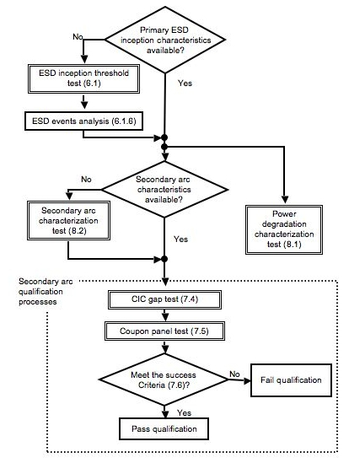
Figure 2: Logic flow of ESD tests
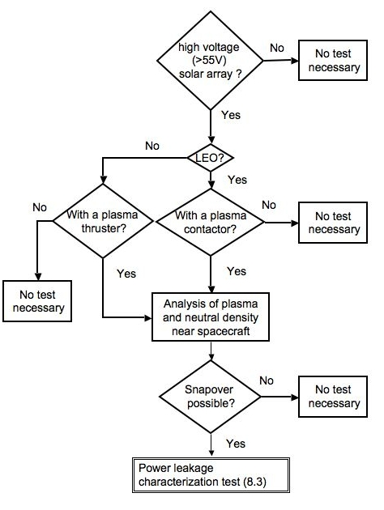
Figure 3: Logic flow of power leakage test

Preliminary Tests for ESD statistics

ESD inception threshold

Purpose
The purpose of this test is to characterize ESD (primary discharge) inception threshold in terms of differential voltage between coverglass and solar array circuit. This differential voltage can be used as a tool to estimate the number of ESD events during the mission lifetime in orbit.

Test Facility
The test facility shall be able to simulate the charging processes of a solar array insulator in orbit. If the solar array is for a GEO satellite, the solar array insulator shall be charged using either an energetic electron beam or UV irradiation, or a combination of both in a vacuum chamber with a pressure lower than 3x10⁻³ Pa. The electron energy must be less than 30keV so that the charging takes place mostly over the insulator surface, and not below it. The vacuum chamber for a GEO solar array test shall be equipped with an adequate device to determine the insulator charging potential, such as a non-contacting surface potential probe, preferably mounted on an x-(y) scanning device.
If the solar array is for an LEO spacecraft, the solar array insulator shall be charged by a low energy plasma less than 10 eV, in a vacuum chamber with a pressure that guarantees a collisionless plasma (the mean free paths are longer than the chamber scale length). If the solar array is for a PEO spacecraft and auroral electrons are responsible for differential charging, charging the solar array insulator by an energetic electron beam is recommended. If the solar array is for a PEO spacecraft and low-energy ionospheric ions are responsible for differential charging, charging the solar array insulator by a low energy plasma is recommended.
The test facility shall be equipped with a device to record an adequate image of the test coupon during the test so that ESD locations can be identified either during or after the test.

Test coupon
The test coupon(s) shall consist of at least three strings of three cells to represent a cell surrounded by other cells. It is recommended for the total number of cells on the test coupon(s) to reflect the production variation regarding parameters that may affect the ESD inception threshold such as degree of grouting, coverglass overhang, cell spacing and others. It is recommended to include all the features of flight panel such as bus bars, through-holes, terminal strips, wire harness, holddown, etc. If the solar panel design involves ESD mitigation techniques such as dissipative coating, it is recommended to include the mitigation techniques that represent the flight model as close as possible. It is recommended to consider the worst condition during the life of spacecrafts, such as after thermal cycling, repaired cells and others that may lead to more risk of ESD and secondary arcs.

External circuit
In the test, the vacuum chamber serves as the circuit ground. If the charging situation in space is the inverted potential gradient, the test coupon shall be biased to a negative potential with a DC power supply. If the charging situation is the normal potential gradient, the test coupon may be grounded. See Fig.4 for circuit diagram. A small amount of capacitance may be connected to the DC power supply if a brighter flash of ESD is needed to identify its location. The capacitance value must be limited so that the electrostatic energy dissipated does not cause power degradation of the solar cells on the test coupon(s). The energy less than 5mJ is recommended. As the capacitance of a coupon alone sometimes exceeds the limit, it is recommended not to use an external capacitance for a large coupon (typically more than 20 cells) and to use a high-sensitive camera to record a flash of ESD.

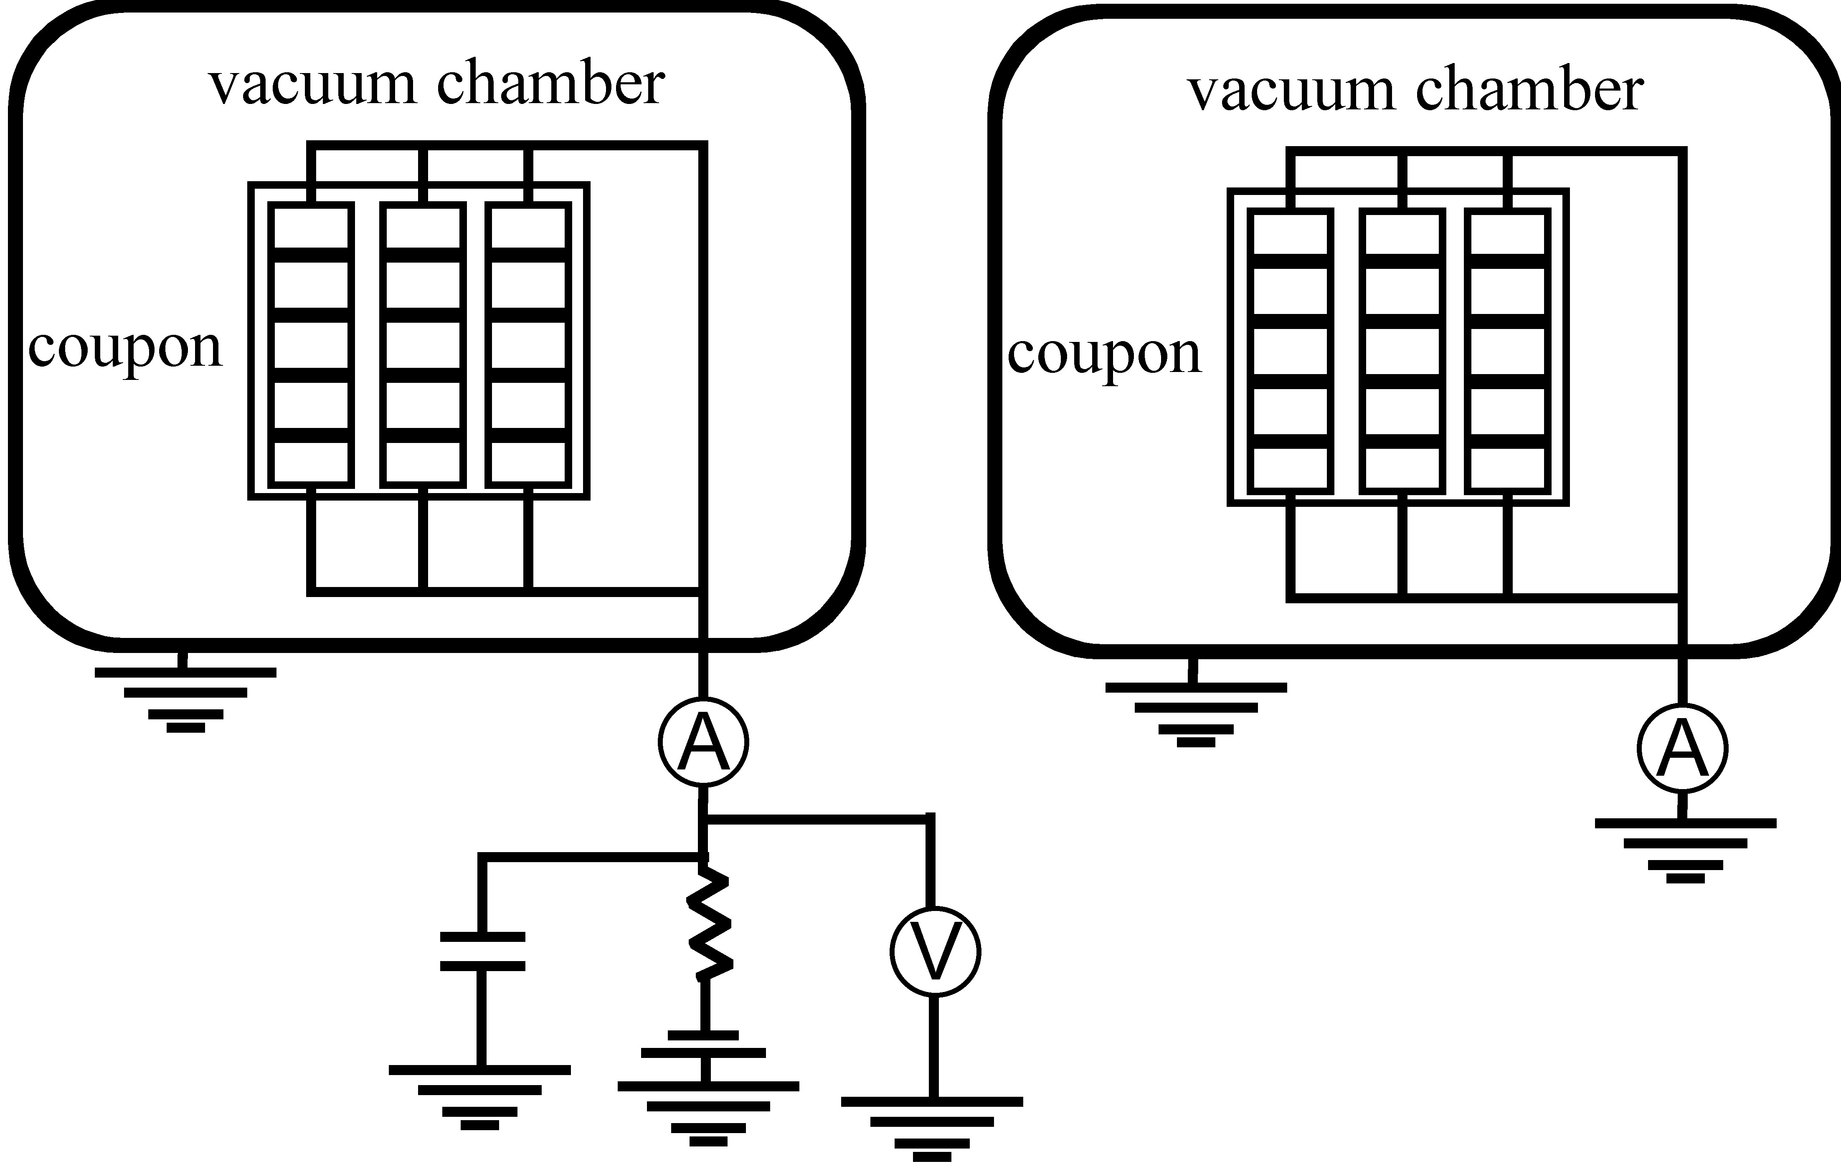
Figure 4: Schematic illustration for the ESD inception test for inverted potential gradient (left) and normal potential gradient (right).

Test procedures
If an electron beam gun or an UV source is used for charging the test coupon, the test shall be done until a statistically significant number of ESD events (typically no less than 10) occur on the test coupon. The test coupon surface potential shall be repeatedly measured during the test by the non-contacting surface potential probe. The minimum differential charging voltage can be derived from analysis of the ESD locations and the test coupon surface potential distribution.
If a low-energy plasma source is used, the differential charging voltage can be approximated by the chamber plasma potential, which is usually somewhat positive, minus the negative coupon potential. The coupon bias voltage shall be varied to cover all the possible charging potentials in orbit. For the case of PEO spacecraft, the waiting time of no less than 20 minutes at each bias voltage is recommended. For the case of LEO spacecraft, the waiting time of no less than 90 minutes at each bias voltage is recommended. At low bias voltages where the probability of ESD is very low, the longer waiting time is recommended to improve the statistics. See Ref.[1] for an example of characterizing the arc rate per given time under the low-energy plasma environment.

Note: If the threshold is unknown, Ref. [2] show the proper technique for establishing it in ground tests. Be aware that the arc rate at a given voltage usually decreases with time in the plasma – do not confuse this with an increase of the arc voltage threshold (see Ref.[2]).

Estimation of number of ESD events in orbit
Once the ESD inception threshold is known, space environment parameters to produce differential charging situations exceeding the threshold can be estimated by spacecraft charging analysis. This estimation is needed in certain situations as cited in sections follow. For given sets of environment parameters, a statistical database can be consulted to calculate the probability of the occurrence of those environments. The time for each differential charging situation to be built up can be calculated. There are several computer programs that can calculate the temporal behavior of differential voltage for a given set of spacecraft geometry, environmental parameters and surface material properties. See Annex B for examples of such software. From the probability of the occurrence and the charging time, the total number of ESD inception during the life of the mission in orbit can be estimated. See Annex C for an example of the estimation method. Different methods of analysis may be used to derive the number of ESD event in orbit.

Qualification Test for Secondary Arc

Purpose
The purpose of this test is to qualify a given design of solar panel for flight. The solar panel design must meet the agreed upon success criteria to pass the qualification test. The purpose of the CIC gap test (7.4) is to show that no damaging secondary arc occurs even when primary discharges are forced to occur directly on the active CIC gap, which is a possible worst case. The purpose of the panel test (7.5) is to show that no damaging secondary arc occurs even after a significant number of primary discharges occur all over the flight representative test coupon.

It may not be always possible to represent the worst condition in orbit via the ground experiment, such as the low temperature at the end of eclipse, the effects of thermal cycling on gap distance and grouting and the outgassing period in orbit. The best effort shall be made, however, to simulate the worst condition or extrapolate the test result to obtain the result that would have been obtained in the worst case.

Triggering method and test facility
If it can be confirmed that the probability of a transition from a primary discharge to a secondary arc does not depend upon the method of primary discharge inception, any method can be used to cause primary discharges, irrespective of the anticipated charging situation in orbit. If the transition probability depends upon the testing plasma environment, the same test facility as used for the primary discharge inception threshold test shall be used. In either case, the primary discharge current shape and amplitude in the test shall be representative of the current expected in orbit.

There is a risk of primary discharge and subsequent secondary arcs in LEO even for a GEO spacecraft as it passes LEO during the transfer. Also, if a plasma emission device is used, such as a plasma contactor, LEO-type arcing may occur when the device is first turned on or off. Therefore, for a GEO spacecraft, it is recommended to do the test for the situation in LEO-type plasma in addition to the GEO-type test.

The test shall take place under vacuum in a test chamber with a pressure that guarantees the collisionless plasma if a low energy plasma is used, or lower than 3x10⁻³Pa if other triggering methods such as an energetic electron beam, UV ray, laser pulse, etc., are used. The test facility shall be equipped with a power supply capable of reproducing the dynamic response of the array to transient short-circuits (such as limited overshoot current and fast recovery to the steady state), simultaneous ESD current transient monitoring and recording devices, and a video imaging device.

External circuit
The cells need not to be illuminated, but available current and capacitance shall be simulated by power sources and external capacitors C_{SAT} and C_{SA} representing the satellite and solar array coverglass capacitances. The capacitance of the missing coverglass shall be included in the test. It is advised to assume the worst case where the surface flashover extends at least two meters radius on a solar paddle absorbing the electrostatic energy stored on the coverglass in the area. The present best estimate of the propagation speed of surface flashover in inverted potential gradient is 10km/s for a GEO solar array under inverted potential gradient. See Refs. [3] and [4] for examples of the current waveform derivation. If a mitigation method against flashover current is included in the design, the effect shall be taken into account in sizing energy in the capacitance C_{SA}.

It is recommended to make the inductance of the wire harness representative of a flight solar panel. Excessive inductance shall be avoided as it affects the transient current waveform. Short cable lengths or coaxial cables reduce the unwanted inductance. See Annex D for details of the external circuit for the case of inverted potential gradient. If testing under normal potential gradient is imperative, the care shall be taken to provide the representative flashover current to the primary discharge.

CIC gap test coupon and procedures
The test coupon(s) shall consist of at least two strings of two cells to represent a point surrounded by solar cell corner edges. The total number of test coupon(s) shall reflect the production variation. The solar cells shall be laid down on the substrate in the same manner as the flight model. The substrate shall be also made of the same material as the flight model. If the solar panel design includes ESD inception mitigation, it is recommended to include the mitigation design in the test coupon as flight-representative as possible.
Before the test, a visual inspection of the test coupon shall be performed with an optical microscope. Output power shall be measured under an appropriate light source. After the test, the visual inspection shall be performed again. The output power shall be measured using the same light source as the one used before the test. Insulation across the cell gap shall be checked before and after the test. Insulation between the cells and the substrate shall be checked before and after test.
It is permitted to concentrate primary discharges on the cell gap. The gap voltage and the string current shall include the 20% over the maximum design gap voltage and current as margin. The test shall ascertain that at least ten primary discharges per given test condition occur in the active gap （or the vicinity of the active gap for the case of grouted gap）where the potential difference is applied and the solar array power available.

Panel test coupon and procedures
The test coupon shall consist of at least three strings of three cells to represent a cell surrounded by other cells. The coupon shall be a flight-representative qualification coupon that covers the production variation of the string gap distance and CIC cell configuration (coverglass overhang, adhesive thickness, etc.). The solar cells shall be laid down on the substrate in the same manner as the flight model. The substrate shall be also made of the same material as the flight model. If the solar panel design includes ESD inception mitigation, it is recommended to include the mitigation design in the test coupon as flight-representative as possible.

Before the test, a visual inspection of the test coupon shall be performed with an optical microscope. Output power shall be measured under an appropriate light source. After the test, the visual inspection shall be performed again. The output power shall be measured using the same light source as the one used before the test. Insulation across the cell gap shall be checked before and after the test. Insulation between the cells and the substrate shall be checked before and after test.
The total number of primary discharges on the coupon shall be determined by a statistical analysis while allowing at least a factor of two margin of accuracy or an industrial statistical standard agreed with the customer. The total number of ESD events derived in 6.1.6 is useful to determine the number of primary discharges. The coupon shall be exposed to the charging environment as it is in orbit without any control over the primary discharge locations. The gap voltage and the string current shall include the 20% over the maximum design gap voltage and current as margin.

7.6 Success criteria
The test shall demonstrate that no temporary sustained arc occurs or no permanent short-circuit of a solar array string occurs due to ESD.

Characterization Tests

Power degradation

Purpose
The purpose of this test is to characterize power degradation due to repeated ESDs after the lifetime in orbit. As the present knowledge about the power degradation is not mature enough to list power degradation as a qualification item, the power degradation is measured for characterization purpose only. As knowledge and evidence accumulate in the near future, the characterization test for power degradation may be promoted to a qualification test.
Note that EMC test (e.g. current injection test or in-rush current test) is not equivalent to ESD test in vacuum. While the ESD test in vacuum can cover all the possible degradation mechanisms including arc current concentration on solar cell edge, the test in air can cover only a limited number of degradation mechanisms such as surge voltage. The current injection test, however, may be useful because of its easiness. See Annex E for the test method in air.

Test facility
The test facility shall be the same as the one used for the ESD inception threshold test (6.1.2).

Test coupon
The CIC solar cells on the test coupon(s) shall be of flight quality. The solar cell, coverglass, adhesive (both for coverglass and substrate) and interconnector shall be the same type and material as the flight models. The light current-voltage (I-V) characteristics before the test shall meet the customer specification as flight quality. The substrate needs not to be the same material as the flight model.

External circuit
An external circuit shall provide additional electrostatic energy that would have been provided by insulator capacitance not accommodated inside the vacuum chamber. The current waveform supplied by the external circuit shall be representative of the surface flashover current in orbit. The electric architecture of a solar paddle has to be taken into account to determine the waveform. It is advised to assume the worst case where the surface flashover extends over two meters on a solar paddle absorbing the electrostatic energy stored on the coverglass in the area. The present best estimate of the propagation speed of surface flashover is 10km/s for a GEO solar array under inverted potential gradient. See Refs. [3] and [4] for examples of the current waveform derivation.

Test procedures
Before the test, a light current-voltage (I-V) characteristics measurement shall be carried out using an appropriate light source. The intensity of the light source shall be calibrated using a standard cell. The exact conditions of the light I-V measurement shall be based on an appropriate solar cell calibration standard whose selection is agreed with the customer. A visual inspection shall be performed with an optical microscope. The test coupon shall suffer the adequate number of ESD events. This value can be obtained in any one of the following: 1)the total number of ESDs from the estimate of events during the mission in orbit (cf. 6.1.6), 2) the testing can stop when 10 consecutive discharges do not create cell degradation beyond the statistical significant level or 3) a number agreed upon with the program customer. The measurement of dark current with a DC power supply is advised to do in-situ monitoring of the progress of degradation during the test. For the measurement of the dark current, see Annex F for details. After the test, the I-V measurement with the same light source and the visual inspection are repeated. In the end, the total drop of spacecraft power at the end of mission lifetime shall be derived.

Secondary arc

Purpose
The purpose of this test is to characterize the secondary arc for a given design of solar panel. The characteristics include the probability of transition from a primary discharge to a secondary arc and the duration of secondary arc if the transition probability is not zero. If the characteristics are already known from the past experience, this test is not necessary to qualify the solar panel for secondary arc.

Triggering method and test facility
Same as 7.3.

Test coupon

The test coupon(s) shall consist of at least two strings of two cells to represent a point surrounded by solar cell corner edges. The total number of test coupon(s) shall reflect the production variation. It is recommended to keep the cell gap spacing within ±200µm from the specification. The solar cells shall be laid down on the substrate in the same manner as the flight model. The substrate shall be also made of the same material as the flight model.

External circuit

Same as 7.3

Test procedures
Before the test, a visual inspection of the test coupon shall be performed with an optical microscope. Output power shall be measured under an appropriate light source. After the test, the visual inspection shall be performed again. Insulation across the cell gap shall be checked before and after the test. Insulation between the cells and the substrate shall be checked before and after test.
It is permitted to concentrate primary discharges on the cell gap. For each set of the gap voltage and the string current that is agreed with the customer but at least includes the 20% over the maximum design gap voltage and current, the probability of transition from primary discharge to secondary arc shall be derived. The test shall ascertain at least ten primary discharges per given test condition occur in the active gap (or the vicinity of the active gap for the case of grouted gap). If there is a need to identify the confidence level of the transition probability, a significant number of primary discharges agreed with the customer based on statistical discussion per given test condition shall occur in the active gap. If the transition probability is not zero, statistics of secondary arc duration, such as the mean and the standard deviation, is useful to extrapolate the probability of damaging secondary arc with a very long duration. If any statistical distribution function is proposed to describe the secondary arc duration, its goodness of fit shall be determined by an appropriate method such as the chi-square statistic.

Power leakage to plasma

Purpose
The purpose of this test is to characterize the power leakage from solar array to the surrounding plasma. The plasma density and neutral gas density near the spacecraft shall be analyzed first. If the densities are too low for possible snapover, this test is not necessary.

Test facility
The test shall take place under vacuum in a test chamber equipped with a low energy plasma source capable of generating the plasma density expected around the solar array in orbit. The plasma species do not have to be the same as those in orbit. A best effort shall be made to realize a plasma temperature similar to the value in orbit. The neutral background pressure shall be kept below 0.01Pa so that unrealistic electron-neutral collisions do not affect the test results. The test facility shall be equipped with a DC power supply capable of supplying several amperes of current at several hundred volts, a recording device to monitor the collection current and the coupon potential simultaneously, a video imaging device and a plasma diagnostic device to determine the chamber plasma properties including the plasma potential with respect to the chamber wall.

Test coupon
The number of CIC solar cells per coupon shall be as great as possible, at least three strings of three cells in series. The use of mechanical CIC cells is acceptable as long as all the conductive part including the cell edge and interconnector is exposed in the same manner as the flight model. The substrate material shall be flight-representative.

External circuit
Both ends of the P and N electrodes of an array may be combined and connected to a DC power supply as illustrated in Fig. 5. The cells need not be illuminated during the test.

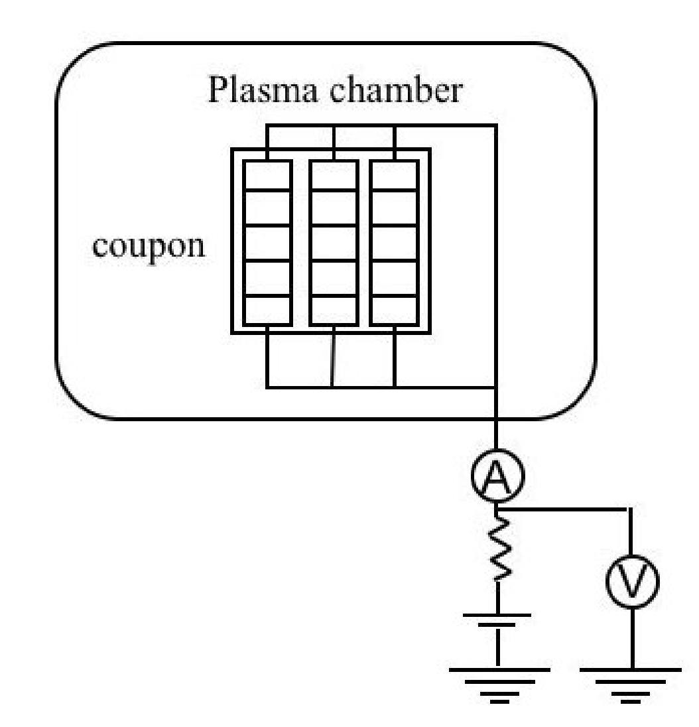
Figure 5: Schematic of circuit diagram for the characterization test of plasma power leakage.

Test procedures
Before the test, the solar array coupon shall be visually inspected with an optical microscope. The test coupon bias voltage shall be changed step-wise while monitoring the potential of the coupon with respect to the plasma potential until the potential reaches the maximum solar array output voltage in orbit. The current collected at each potential shall be recorded after the current has become steady. After the test, the visual inspection shall be repeated. In the end, the overall power leakage from the spacecraft to the plasma shall be derived.

Test Report Guidelines
The ESD test report shall include the following information:
- A title
- Test facility description (i.e., chamber size, chamber pressure, charging method, power supply, recording device, etc) with photographs of the test set-up.
- Test coupon description (i.e., solar cell type, solar cell quality, number of coupons tested, etc)
- External circuit diagrams for each test case identifying the value of each circuit element. It is recommended to identify any floating capacitance and inductance involved in the circuits.
- Test results. Summarize all visual inspections and include photographs of the test coupons before and after the tests. In graphs, error bars shall be shown to represent uncertainty in the test when applicable.
- Summary of qualification tests: Indicate whether the solar panel family passed or failed qualification.
Annex A
(informative)
Plasma Interaction and Electrostatic Discharge Effects on Solar Array

A.1 Plasma Environment in Orbit
For detail of the orbital plasma environment, see Refs. [5], [6], [7], [8] and [9]. Generally speaking, GEO is characterized by the presence of electrons with energies greater than 1keV. During quiet conditions, the electron current is less than the photoelectron current, which is of the order of 1 to 10µA/m², and there is no serious surface charging issue. During stormy conditions, the electron current exceeds the photoelectron current and the risk of electrostatic discharge on the solar array surface increases. Several examples of the worst case GEO plasma environment can be found in Refs.[10]. LEO is characterized by the presence of low energy but dense ionospheric plasma, which is of the order of 10⁸ to 10¹²m⁻³. For an object at the plasma potential in LEO, current from electrons of energies 0.1 to 0.2 eV dominates over any other current source to spacecraft. The spacecraft body’s potential floats with respect to the ionospheric plasma potential, within the solar array power generation voltage. PEO is characterized by auroral electrons with energies greater than 1keV, that coexist with the low energy ionospheric plasma. In some cases, the auroral electron current, which can be as large as 1mA/m², may dominate over the other current sources and drive the spacecraft body to a potential more negative than the power generation voltage. When a spacecraft is equipped with an electric propulsion system, the artificial plasma may dominate the plasma environment around the spacecraft, especially in GEO.

A.2 Spacecraft surface charging

The spacecraft body that is made of conducting material serves as a grounding point in the spacecraft circuit. Currents to/from conductive parts exposed to space, and the capacitance between the spacecraft body and ambient space determine the body potential with respect to the ambient space plasma. As the solar array circuit is also grounded to the spacecraft body, any point on the solar array circuit has a potential close to the spacecraft body’s potential within the power generation voltage. When the negative end of a solar array circuit is grounded, the potentials on the solar array conductive parts have a distribution from the body potential to the body potential plus the power generation voltage.

In GEO, differential charging on the solar array surface may develop when the spacecraft encounters a high flux of energetic electrons. Conductive parts of the solar array such as the solar cell electrode, interconnector, or bus-bar have a negative potential bounded by the spacecraft body potential. Insulator parts, such as the coverglass, adhesive, or facesheet, also have negative potentials, but the values can be different from the body potential by kV or greater. In PEO, a situation similar to GEO may arise when the spacecraft encounters the aurora and the solar array front surface is facing the wake side. When the solar array front surface is facing the ram side in PEO, the aurora may drive the spacecraft body potential negative and the insulator surface may be charged by ionspheric ions to a potential close to the ambient plasma potential. In LEO, differential charging on the solar array surface appears as the insulator parts have potentials close to the ambient plasma potential and the conductive parts have potentials ranging from the negative of the power generation voltage to the positive of the power generation voltage. Therefore, for LEO spacecraft, ESD and PI issues arise only when the power generation voltage exceeds the primary arc or snapover threshold voltage.

One can assess spacecraft surface charging with the aid of computer simulations. There are several computer programs that can calculate the differential voltage for a given set of spacecraft geometry, environmental parameters and surface material properties. As ESD occurs during a transient phase of differential charging in GEO and PEO when a differential voltage develops due to an encounter with a substorm or aurora, it is important for the programs to be able to calculate the transient behavior in addition to the steady state behavior. See Annex A for examples of such software. Although the computer simulation tools can give the differential voltage, they cannot predict the discharge inception voltage.

A.3 Electrostatic discharge on solar array

ESD on a solar array is a single, fast, high current transfer of electrostatic charge that results from a strong electrostatic field between two objects in close proximity. Differential charging on solar array exterior surfaces builds up an electric charge on the insulator surface. The electrostatic energy stored on the insulator is partially or fully released once the electric field on any part of the surface exceeds the discharge inception threshold. ESD has three forms of current path. The first is blow-off, which is the emission of negative charges (electrons) into space. The blow-off current discharges electric charge stored in the capacitance between the spacecraft and the ambient plasma. The second is flash-over, which is a surface discharge propagating from a starting point as the surface of the dielectric becomes conductive (by the creation of a plasma). The flash-over current discharges electric charge stored in the capacitance between the surface of an insulator and the spacecraft ground. The third is punch-through, which is the classic breakdown of a dielectric material such as the breakdown of a capacitance for example. The punch-through discharge discharges not only electric charge stored in the capacitance between the insulator and spacecraft ground, but also charge stored inside the insulator material due to penetrating charged particles. The thickness and dielectric strength of typical insulator materials used on solar arrays tends to favour the blow-off and flash-over forms of current path over the punch-through form.

The inception threshold for ESD on a solar array is often measured by the potential difference between the coverglass surface and the spacecraft ground. Although the threshold depends upon numerous parameters such as polarity, geometry, material, ambient atmosphere, etc, the inverted potential gradient (IPG) situation has a smaller threshold (hundreds of volts) than the normal potential gradient (NPG) situation (thousands of volts). IPG ESD has been more thoroughly investigated than NPG ESD. For high voltage LEO spacecraft, IPG is the nominal condition. In PEO and GEO, the secondary electron and photoelectron coefficients of insulator material determines the polarity. As the solar array is illuminated by sunlight during power generation, and the coverglass coating, such as MgF₂, has a very high secondary electron coefficient, IPG is expected to occur more frequently than NPG. As the situation may differ for each spacecraft, however, a charging analysis should be carried out to determine the polarity on the solar array for each spacecraft unless an identical spacecraft design is employed.

Normal or inverted, ESD originates from a micro-discharge at its inception point. For IPG it is believed to be due to the field emission and desorption of gas near the so-called triple junction, where the insulator material, conductor and vacuum (plasma) meet together. For NPG, it may be due to punch-through of a thin dielectric or an electron avalanche triggered by seed electrons produced by various reasons. Due to the negative potential of the spacecraft body and the high mobility of electrons, the blow-off current quickly discharges the satellite capacitance (absolute capacitance), with typical values from 100 to 1000pF. The flashover current follows the blow-off by neutralizing electric charge on the insulator near the ESD inception point. In the case of IPG, the flashover current flows to the inception point and forms cathode spots transforming the ESD into a form of vacuum arc. Therefore, IPG ESD is called a primary arc. The primary arc receives its energy from the electrostatic energy stored in the capacitance between the insulator surface and the spacecraft body (differential capacitance), which is typically much greater than the absolute spacecraft capacitance.

A.4 Detrimental effects of ESD

ESD on a solar array may cause various detrimental effects to the solar array operation. The large transient current may cause electromagnetic interference with spacecraft circuits. As ESD may occur repeatedly during the lifetime of spacecraft, there may be cumulative effects such as surface degradation, surface contamination via vaporized material or internal damage to solar cells due to surge voltages. When ESD occurs at the edge of a solar cell or bypass diode, it may degrade their electrical performance.

“Primary discharge” is the general term of ESD that includes both IPG ESD (primary arc) and NPG ESD. The primary discharge is fed by the absolute and differential capacitances. The primary discharge may create a temporary conductive path between any two cells with different voltages generated by solar array power generation. The current between the two cells can become sustained when fed from the solar array output power. This resulting phenomenon is called a “secondary arc”. The secondary arc is powered by an illuminated solar array and leads to an important additional damage mechanism since the solar array circuit can become permanently short-circuited.

The secondary arc may or may not be self-sustained. There are several stages of a secondary arc as illustrated in Fig.1. Figure 1 illustrates examples of the current waveform seen in secondary arc tests. The primary discharge current is seen as the blow-off current flowing from the external capacitance to the chamber wall through the solar cells. The secondary arc current is seen as the arc current flowing between the two cells through the external power supply that simulates the illuminated solar array. In the figure, I_{sc} represents the short-circuit current of one or more of solar array circuits. A non-sustained arc (NSA) is a secondary arc that lasts only during the primary discharge. It ends when the primary discharge stops. A self-sustained arc is a secondary arc that lasts longer than the primary discharge. A temporary sustained arc (TSA) is self-sustained but it stops by itself even though the solar array power is still available. A permanent sustained arc (PSA) is an arc that does not stop while the solar array power is available. PSA can last for seconds or longer. The very intense heat in the vicinity of the secondary arc creates a highly conductive path by pyrolizing materials around the discharge site. When a solar array is laid down on an insulator face-sheet over a conductive substrate, a pyrolized insulator leaves a permanent conductive path even after the external power is shut-off. The solar array circuit then remains short-circuited to the solar panel ground diverting the solar array power to the panel ground.

A.5 Power leakage from solar array to plasma

The use of a potential control device, such as a plasma contactor, can mitigate ESD-related charging problems on solar array by raising the satellite body potential to a level close to the ambient plasma potential. At the same time, however, it may lead to the problem of power leakage, especially in LEO. The power leakage may be also a problem for a spacecraft with a plasma thruster system that is tied to the spacecraft chassis regardless its orbit. Exposed conductive parts of a solar array collect electrons if their potential is positive with respect to the ambient plasma potential. Part of the solar array power drains into the plasma circuit.

Because most of a solar array’s surface is covered with coverglass, the exposed conductor makes up a tiny portion of the array area. As long as the voltage between the positive conductive parts and the plasma is low, electron collection current is limited by the geometry and scales only linearly with the voltage. As the voltage becomes higher, however, current collection increases exponentially and finally saturates at a current level that is approximately the same as if the entire plate were conducting. The transition is quite striking with conventional solar array designs and has been called “snapover”. When the ambient neutral pressure is high, snapover may be combined with a glow discharge that further increases the electron current. Once the snapover or the glow discharge occurs, power leakage to the plasma is no longer negligible.

Annex B
(informative)
Spacecraft charging analysis
There are a number of simulation codes available for performing surface charging assessments taking into account surface material processes or 3D effects. Historically the most common spacecraft charging code in use by the space industry was the NASA-USAF charging analysis code, NASCAP-GEO. It has been made available to various users via collaboration agreements with NASA or via commercial arrangement. Although NASCAP-GEO has been replaced by NASCAP-2K in the United States, NASCAP-2K is subject to export restriction. Recently JAXA has sponsored the development of MUSCAT and ESA has sponsored the development of SPIS.

The basics of spacecraft surface charging analysis are to calculate the contribution of each current component by following the trajectories of the ambient plasma particles, calculating the interaction between the incident particles and the surface material and considering the emission of charged particles from the surface, such as secondary electron, photoelectron and artificial plasmas. Then, the surface charge distribution is updated based on the current density and conductivity of each surface element relative to the spacecraft body ground. The surface potentials are calculated by solving the Poisson equation or the Laplace equation. Particle trajectories are recalculated for the renewed surface potential and the processes are repeated until the elapsed time reaches the predetermined time or the steady state is obtained. The important features of the charging analysis code are the capability to model the three-dimensional geometry of the spacecraft and important surface interactions such as secondary electron and photoelectron emission and the material property database regarding spacecraft surface material, such as conductivity, secondary electron emission yield and photoelectron emission coefficient.

B.1 NASCAP-GEO: A commonly used code, used for simulating surface charging in the outer magnetosphere, is NASCAP (also called NASCAP-GEO [11]). This code calculates the total current, due to all the current contributions, for each surface on a numerically modelled 3-D spacecraft, using a two Maxwellian environment for both ions and electrons. From these currents, the change in potential at each surface is calculated. The current and potential calculations can be performed iteratively until an equilibrium charging state is achieved.
B.2 NASCAP-LEO: NASCAP-LEO is aimed at the simulation of high potential objects with a cold dense plasma typical of the LEO environment. Like NASCAP-GEO it employs analytical current collection equations, although these are aimed at sheath limited current collection and are appropriate for the short Debye-length LEO plasmas. Typical uses are the simulation of parasitic currents from high potential surfaces, such as solar array interconnects. The geometrical model of the spacecraft is more sophisticated than for NASCAP-GEO, consisting of a finite-element representation.
B.3 POLAR charging code: The main problem with computing charging in LEO is computing effects associated with the spacecraft sheath. The 3-D POLAR code [12] has been designed for the assessment of sheath and wake effects on PEO spacecraft. This uses numerical techniques to track ambient ions inwards from the electrostatic sheath surrounding a negatively charged spacecraft, onto the spacecraft surface. Spacecraft velocity is included as an input and ram and wake effects are modelled. One or two Maxwellian components may be used to define the ambient plasma. The electron population in POLAR is a superposition of power-law, Maxwellian, and Gaussian components. Once the surface currents have been found, POLAR calculates potentials and the equilibrium charging state in a similar way to NASCAP.

B.4 NASCAP-2K: The most recent NASCAP code (NASCAP-2K) is available, free, to US citizens only. This is a comprehensive code with realistic geometry. It is reported to combine the capabilities of NASCAP-GEO, NASCAP-LEO and POLAR. The code is not easily available outside the US.

B.5 SPIS: SPIS[13] is a fully 3D PIC code that allows the exact computation of the sheath structure and the current collected by spacecraft surfaces for very detailed geometries. Surface interactions including photo-electron emission, back-scattering, secondary-electron emission and conduction are modelled. The source code is freely available from www.spis.org and a mailing list provides a limited amount of support.

B.6 MUSCAT: MUSCAT[14] is a fully 3D particle code that can be applied to spacecraft in LEO, PEO and GEO. Its algorithm is a combination of PIC and particle tracking. A parallel computation technique is used for fast computation. It has a JAVA-3D based graphical user interface for 3D modeling of spacecraft geometry and output visualization. The surface interactions included in the NASCAP series and SPIS are modeled. A material property database is also included. The code is commercially available.

B.7 Other surface charging codes: There are a number of other codes available to simulate surface charging. two Russian codes ECO-M [15] and COULOMB [16] perform a very similar function to NASCAP, POLAR and NASCAP-LEO.

B.8 Environment Work Bench: An approximate, quick-look code that includes spacecraft charging in LEO. A variant of EWB is the official charging tool for the International Space Station (ISS) .

B.9 SPARCS: A code developed and used by AAS for simulating surface charging in the outer magnetosphere (GEO). This code compute the total current, due to all the primary and secondary current contributions, for each surface on a finite-element type geometrical model of the spacecraft. Physical phenomena accounted for the secondary current budget are electron photo-emission, back-scaterring and secondary cascade emission and secondary electron recollection. SPARCS uses a two Maxwellian environment for both ions and electrons. From these currents, the change in absolute potential of the spacecraft and in potential at each surface is calculated. Environmental conditions can be changed during computation for a simulation of a end-of-eclipse. SPARCS can be made available commercially upon request.
Annex C
(informative)
ESD events analysis
Estimation of the number of ESD events in orbit can be done in the following steps [17];
- List-up of space plasma environment that a given spacecraft will encounter in the orbit
- Spacecraft charging analysis for each case of space plasma environment
- Identification of plasma environment cases that gives the differential voltage exceeding the ESD inception threshold
- For each case identified in the step 3, calculate the charging time necessary to reach the threshold value.
- Derive the probability of occurrence of each case identified in step 3 and the expected total duration in orbit
- Divide the expected total duration obtained in the step 5 by the charging time obtained in the step 4 to obtain the expected number of ESD events for each case exceeding the ESD inception threshold
- Take the sum of the numbers of ESD event to derive the total number.

More details can be found in Ref.[17].

In the first and fifth step, a proper database regarding the space plasma environment should be consulted. An example for GEO database is the Los Alamos National Laboratory (LANL) satellites data that is available on internet [18], where the magetospheric plasma analyzer (MPA) data are listed for electron density, electron temperature, ion density and ion temperature between 1eV and 45keV measured by the multiple LANL satellites at every 90s since 1993. An example for PEO database is the Defence Meteorological Satellite Program (DMSP) satellites data. The auroral electron data is available on internet [19], where the SSJ/4 (Precipitation Electron/Proton Spectrometer) data are listed for the precipitating electron flux between 30eV and 30keV measured by the multiple DMSP satellites at approximately 840km at every second sine 1983. The ionospheric low temperature ion data is available on internet [20], where the Special Sensor-Ions, Electrons, and Scintillation (SSIES) data are listed for electron density, electron temperature, ion density and ion temperature measured by the multiple DMSP satellite at every 4 s since 1987.

In the second step, a proper spacecraft charging analysis tool should be used. Annex B provides the list of the computer program currently available. The differential voltage between the coverglass and the spacecraft body should be calculated for a given set of the environmental parameters. It is recommended to calculate the worst case first, as there will be no need of further analysis and ESD test if the worst case simulation shows no possibility of the differential voltage reaching the ESD inception threshold. It should be noted that the charging analysis result often depends strongly on the spacecraft material property. Even if the worst case simulation shows no serious charging, the result should be confirmed by varying the material data within possible range of the parameters.

Figure 6 illustrates how the charging time can be calculated in the fourth step. In this example, NASCAP/GEO was used to calculate a GEO satellite. The plasma parameters are also listed in the figure. The simulation starts from the condition where both the satellite and coverglass potentials are zero. As the charging start, the differential voltage gradually builds up. If the ESD inception threshold is 400V, the threshold is reached in 20 seconds. Once the threshold is attained, an ESD occurs somewhere on the solar paddle and the satellite body potential goes back to zero. By assuming that the differential charging is initialized by one ESD, the process of charging and ESD is repeated as long as the harmful plasma environment continues.

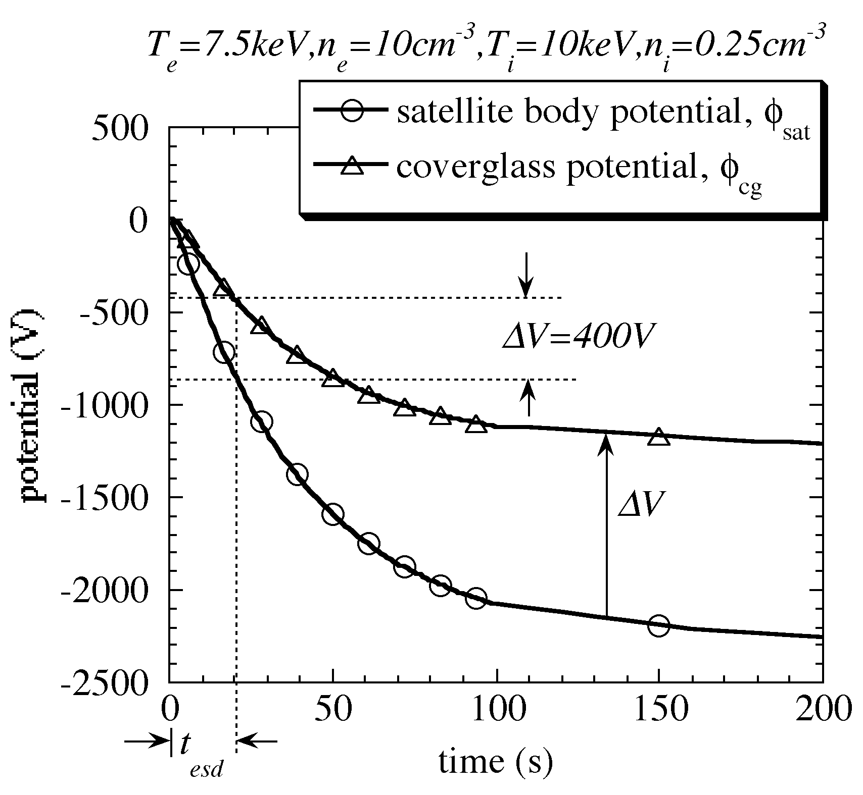
Figure 6: Example of charging profile calculated for a GEO satellite. If the ESD inception threshold is 400V, the time to reach the threshold differential voltage (t_{esd}) is 20 second for this case [17].

Table 1 illustrates how the number of ESD events in one year is derived. Using the result of statistical analysis in the fifth step, the expected duration of each plasma environment can be calculated for each local time zone in GEO. For each case, the charging analysis in the fourth step provides the time to reach the threshold. In the table N/A indicates that the differential charging does not reach to the threshold value even at the steady state. The number of ESD for each case is calculated by dividing the duration by the time to reach the threshold.

Table 1: Example of deriving the number of ESD events for a GEO satellite [17].
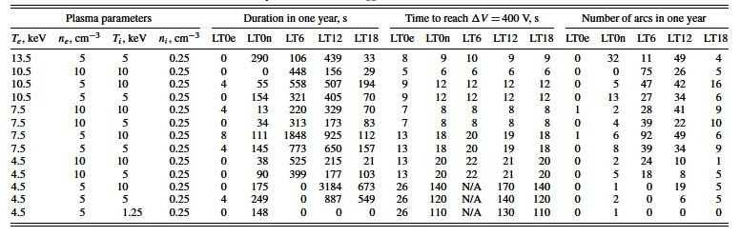
Annex D
(normative)
External circuit of secondary arc test
Figure 7 schematically illustrates a recommended circuit layout of secondary arc test representing IPG.

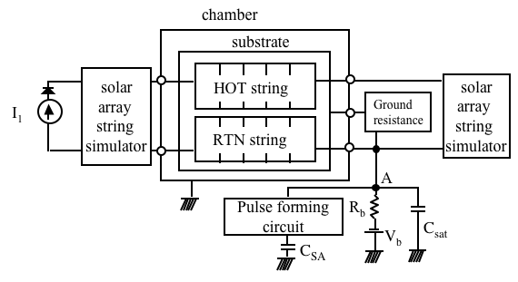
Figure 7: Recommended circuit layout of a secondary arc test representing IPG.

The HOT string represents solar cells at a positive potential with respect to the spacecraft chassis and the RTN string represents solar cells close to the spacecraft chassis.The power supply V_{b} represents the charging potential of the spacecraft body. It is recommended to insert the resistance R_{b} to isolate the power supply from the circuit during the transient. The easiest way to detect the occurrence of a primary discharge is to monitor the voltage between the point A and the ground. The vacuum chamber serves as the circuit ground.
The circuit has two capacitors that simulate the energy source in primary discharge. The capacitor, C_{SAT}, represents the capacitance between the satellite body and the ambient plasma. As this is usually in the order of 100pF to 1000pF, it may be substituted by the floating capacitance between the circuit and ground. The wire harness alone often has a capacitance greater than 100pF. The capacitor, C_{SA}, represents the capacitance between the exterior insulator surface and the spacecraft ground that provides the electrostatic energy as the surface flashover current. Because C_{SA} is charged by the power supply V_{b}, the value of C_{SA} must be adjusted so that the current provided by C_{SA} is representative of the surface flashover current in orbit. The fact that the surface flashover propagates with a finite speed shall be taken into account. The use of a pulse forming circuit such as the insertion of inductance and resistance is recommended to delay the energy injection from C_{SA}. Dividing C_{SA} into small parallel capacitances that are individually connected in series with time-delayed switches also provides a representative energy comparable with primary discharge. Care shall be taken to make sure ringing or other side effects non-representative of situation in orbit do not occur. Though the wire harness must be representative of a flight solar panel, it is recommended to minimize the cable length or to use co-axial cable to reduce unwanted excessive inductance.

The solar array string simulator at the right of Fig.7 may be opened, short-circuited or inserted with resistance. The string simulator may include all or some of the spacecraft internal circuit elements, e.g. blocking diodes, a bypass capacitance, load resistance, shunting electronics and so on. Care must be taken to ensure:
- All the available current from at least a string of the solar array circuit, i.e., the short-circuit current, becomes available to a secondary arc once the resistance of the secondary arc plasma drops significantly low. Use of a diode switch described in Refs.[9] and [21] is recommended.
- The voltage between the hot and return strings is not increased too much by the surge voltage induced by the primary discharge current to the hot string. If the load simulator is open or has only resistive components, the passage of the primary discharge current produces a high voltage drop, especially when a large C_{SA} is used. It is recommended to insert a large capacitance (approximately 10mF or more) in the load simulator representing the bus capacitance, providing a path for the high frequency primary discharge current and producing a smaller voltage drop.

The power supply I₁ represents the power generated by the solar array. The insertion of a diode is recommended to protect the power supply from the primary discharge hitting the hot-string. The power supply must be capable of reproducing the dynamic response of the array to transient short-circuits such as limited overshoot current and fast recovery to the steady state. The solar array string simulator may include string capacitance and face sheet capacitance. The string capacitance is the capacitance associated with the differential mode between the two ends of the string. The face sheet capacitance is the capacitance between the solar cells and the conductive substrate through the adhesive and polymer face-sheet. See Refs.[9] and [21] for details of the derivation of these capacitances. If the blocking diodes do not isolate every solar array string circuit, one must consider that all of the solar array strings grouped by each blocking diode give power to a secondary arc. Then, either the power supply I₁ shall provide the total power or the solar array string simulator shall include power supplies to represent contributions from the non-arced strings. See Refs.[9] and [21] for details.

Specific examples of the circuit diagrams that are used in Japan and France, respectively are shown in Figs.8 and 9. The capacitance C_{GS} in Fig.8 has the same meaning as C_{SA} in Fig.9.

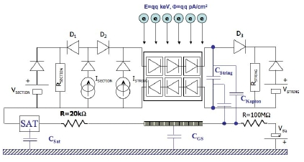
Figure 8: Example of the circuit layout of a secondary arc test representing IPG adopted in France (Ref.[6]).
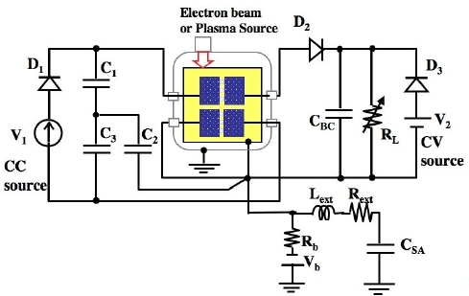
Figure 9: Example of the circuit layout of secondary arc test representing IPG adopted in Japan (Ref.[22]). The capacitance C_{BC} is a bypass capacitance.

Annex E
(informative)
Solar cell current injection test

TBD
Annex F
(informative)
Solar cell I-V characteristics measurement
It is recommended to measure the I-V characteristics under illumination at the same facility before and after the test as the relative change in the electrical performance is more important than the absolute performance value. The illuminated I-V curve measurement needs not be done at the same location as the ESD/PI tests.

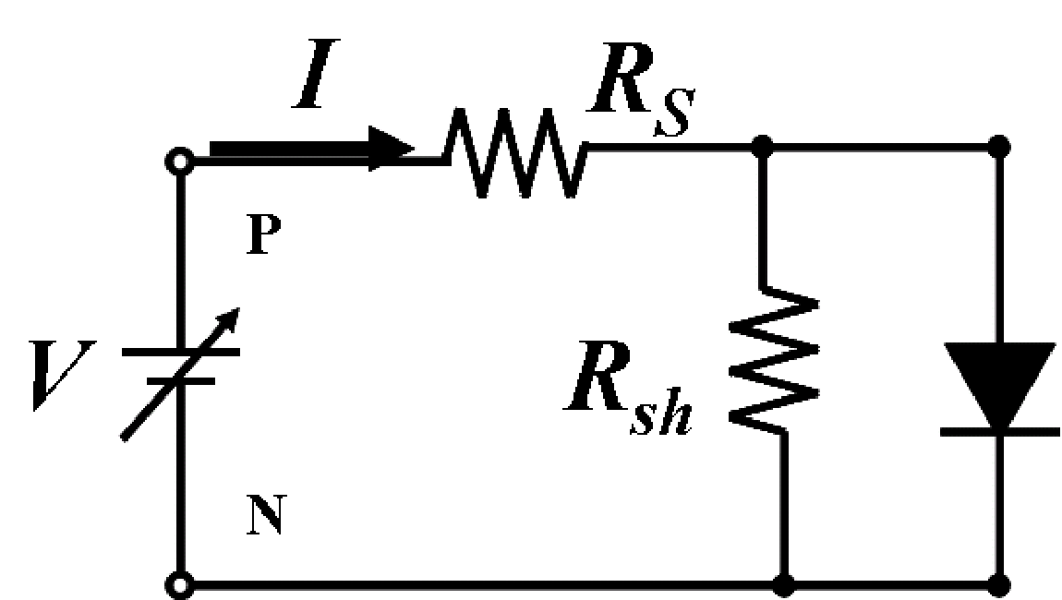
Figure 10: The equivalent circuit of a solar cell in dark conditions with an external DC power supply

It is useful to measure the dark current in-situ to monitor the performance degradation. Figure 10 illustrates the equivalent circuit of a solar cell in dark conditions. It consists of a diode, parallel shunting resistance, R_{sh}, and series resistance, R_{s}. The relationship between the current I and the voltage V applied by the external DC power supply is given by
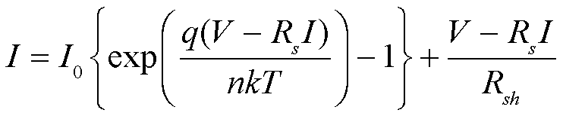 (1)

where I₀ is the reverse saturation-current density [A/m²], T [K] is the temperature, k is the Boltzmann constant, n is the diode constant and q is the elementary charge. When a solar cell degrades due to ESD, it appears as a decrease in parallel resistance, increase in series resistance, or a change in diode properties I_{o} and n. In many cases the decrease of the shunt resistance is the most notable and it can be easily found by plotting the dark I-V data in a semi-logarithmic plot as shown in Fig. 11. In this example, as R_{sh} is too low, even if the cell is illuminated, most of the photo-generated power leaks to R_{sh} instead of going to the load.
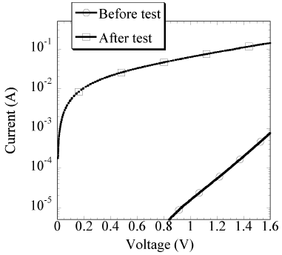
Figure 11: An example of the dark I-V characteristics of a solar cell before test and after test with an R_{sh} decrease
Annex G
(informative)
Solar array back surface test
Although the scope of this standard is surface discharge and plasma interaction on solar array front surface, we cannot exclude the possibility of ESD and plasma interaction on solar array back surface. Reference [23] describes an example of ESD test on solar array back surface.

As there is no solar cell on the back surface, secondary arc and power leakage are the major concern. Solar array back surface often has exposed metallic parts such as diodes, connectors, holddown, etc. If the metallic parts are adjacent to other parts with a different voltage, primary ESD on solar array back surface may lead to a secondary arc between the two parts and subsequent permanent short-circuit. The metallic parts may attract electrons from the surrounding plasma if its potential with respect to the plasma is high, resulting in the power leakage to the plasma.

The same test facility and procedure as the test on front surface can be applied to the test on back surface, except the test coupon. The test coupon should be made in the same manner as the flight solar panel, including the substrate. All the features of flight panel such as diode boards, connectors, etc should be included. The test flow for secondary arc is the same as the front surface. First, the ESD inception threshold should be measured as described in 6.1 using a charging method representative of the orbital condition. Many charging analysis software are capable of calculating the back surface differential charging at the same as it calculates the front surface charging. Therefore, it is possible to estimate the number of ESD events in orbit as described in 6.1.6 and Annex C. Secondary arc test on back surface can be done in the same manner as in 7.2 and 7.5 using the flight representative back surface coupon. The same external circuit as in 7.3 and Annex D can be used although the care should be taken to derive the value of external capacitance as the flashover extension is now over the insulator on back surface.

The power leakage test on back surface can be done in the same manner as in 8.3 except the test coupon. The same test coupon used for back surface ESD test can be used for the plasma leakage test. As most of spacecraft uses negative grounding of solar array circuit, power leakage to the solar panel substrate is not concern. Exposed metallic parts with the same potential as the positive end of solar array circuit such as blocking-diodes have the highest risk of the serious power leakage. Those parts should be included in the test coupon.

Bibliography
[1] Vayner, B., Galofaro, J., and Ferguson, D., “Interactions of High-Voltage Solar Arrays with Their Plasma Environment: Ground Tests”, Journal of Spacecraft and Rockets, Vol.41, No.6, 2004, pp.1031-1051
[2] “The voltage threshold for arcing for solar cells in LEO: Flight and ground test results”, Ferguson, D.C., NASA-TM-87259 or AIAA PAPER 86-0362 , 1986
[3] P. Leung, “Plasma Phenomena Associated with Solar Array Discharges and Their Role in Scaling Coupon Test Results to a Full Panel”, AIAA 2002-0628, 40th Aerospace Sciences Meeting & Exhibit, Reno,January, (2002)
[4] E. Amorim, D. Payan, R. Reulet, D. Sarrail “Electrostatic discharges on a 1m2 solar array coupon influence of the energy stored on coverglass on flashover current” 9th spacecraft charging technology conference, Tsukuba, Japan, April, (2005)
[5] ISO TS 16457 Space Environment (Natural and Artificial) − Earth’s Ionosphere Model: International Reference Ionosphere and Extensions to the Plasmasphere.
[6] http://nssdc.gsfc.nasa.gov/space/model/
[7] Low Earth Orbit Spacecraft Charging Design Guidelines, Ferguson, D.C., and Hillard, G.B., NASA/TP-2003-212287
[8] NASA-STD-4005, Low Earth Orbit Spacecraft Charging Design Standard
[9] ECSS-E20-06, Space Engineering – Spacecraft Charging
[10] Design Guidelines for ‘ Assessing and Controlling Spacecraft Charging Effects, Purvis, C.K., Garret H.B., Whittlesey, A.C., and Stevens J.N., NASA Technical Paper 2361, 1984
[11] Katz I., J.J.Cassidy, M.J.Mandell, G.W.Schnuelle, P.G.Steen and J.C.Roche, `The Capabilities of the NASA Charging Analyzer Program', in `Spacecraft Charging Technology -1978', Ed. R.C.Finke and C.P.Pike, NASA CP-2071/AFGL TR-79-0082, ADA045459, p.101,1979
[12] Lilley J.R., Cooke D.L, G.A.Jongeward and I.Katz `POLAR User's Manual', AFGL-TR-85-0246.
[13] Forest, J. , Eliasson, L. and Hilgers, A. : A New Spacecraft Plasma Interactions Simulation Software, PicUp3D/SPIS, Proc. 7th Spacecraft Charging Technology Conf. , (2001), pp.515-520.
[14] Hatta S., Muranaka, T., Hosoda, S., Kim, J., Cho, M., Ueda, H., Koga, K., Goka, T., :MULTI-UTILITY SPACECRAFT CHARGING ANALYSIS TOOL (MUSCAT): DEVELOPMENT OVERVIEW, Proc. 9th Spacecraft Charging Technology Conference, Tsukuba, Japan, April, 2005.
[15] Vasilyev Ju.V, V.V.Danilov, V.V.Danilov, V.M.Dvoryashin, A.M.Kramrenko and V.S.Sokolv, `Computer Modeling of Spacecraft Charging Using ECO-M', Proc.International Conference of Problems of Spacecraft/Environment Interactions, June 15-19, 1992 Novisibirsk, Russia, p.187, 1993.
[16] Soubeyran, A.; Drolshagen, G.; Levy, L.; Matucci, A.; Kensek, R.P.; Betz, G.; Fehringer; Rudenhauer, F.G., "Deep Dielectric Charging Simulation New Guidelines", in IEEE proceedings of Radiation Effects Data Workshop, IEEE, 21 July 1993, pp.93 – 98, 1993.
[17] “Number of arcs estimated on solar array of a geostationary satellite”, Cho, M., Kawakita, S., Nakamura, S., Takahashi, M., Sato, T., Nozaki, Y., Journal of Spacecraft and Rockets, vol.42 no.4, pp.740-748, 2005.
[18] http://cdaweb.gsfc.nasa.gov/
[19] http://sd-www.jhuapl.edu/Aurora/index.html
[20] http://cindispace.utdallas.edu/DMSP/
[21] Payan, D., Schwander, D. and Catani, J. P.: Risks of low voltage arcs sustained by the photovoltaic power of a satellite solar array during an electrostatic discharge. Solar Array Dynamic Simulator, 7th Spacecraft Charging Technology Conference, April 2001.
[22] Masui, H., Kitamura, T., Okumura, T., Toyoda K., and Cho, M., “Laboratory Test Campaign for ISO Standardization of Solar Array ESD Test Methods”, AIAA 45th Aerospace Science Meeting, 2007
[23] Cho, H., Kim, J., Hosoda, S., Nozaki, Y., Miura, T., Iwata, T., “Electrostatic Discharge Ground Test of a Polar Orbit Satellite Solar Panel", IEEE Transaction on Plasma Science, Vol.34, pp.2011-2030, 2006

